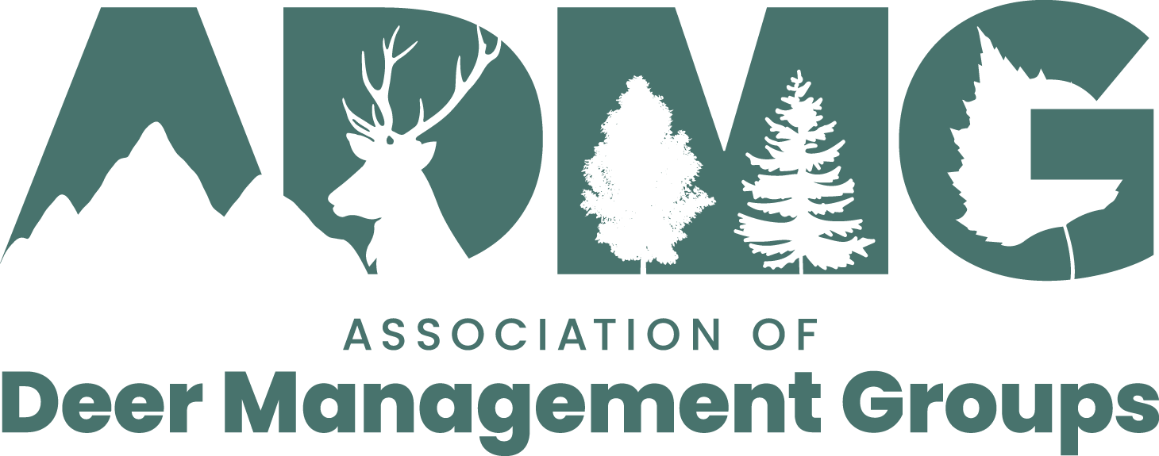
Application to the ADMG Deer People Fund
Name:
Current address:
Date of birth:
Formal qualifications and completed training
1.
2.
3.
4.
5.
Work experience
1.
2.
3.
4.
5.
Personal statement
Please explain your interest and motivation in applying for a placement below.

Signature:
Date:
Please submit your completed application to rc.doolally@outlook.com
or by mail to Richard Cooke, Colthill, Edzell, Angus DD9 7FA

